Atmel AVR Design Contest 2006

August 16, 2006

Entry # AT3296

ATir Keyboard Interface

Featuring the Atmel ATtiny45 Microcontroller

Introduction
The human interface to most PC’s consists of a keyboard and mouse. While this is convenient for many tasks conducted with a computer, some applications warrant remote operation. For example, when conducting a Power Point slide presentation, it is nice to be able to advance the slides without having to operate the keyboard. Some PC’s are used to run dedicated multimedia applications in a home theater environment, where it is easier to press the play button on a remote control than to operate a keyboard. Some industrial systems use PC’s running a custom software application that may only require a small set of keyboard commands to operate while most of the time the keyboard remains unutilized and collecting dust. These are just some of the applications that could benefit from the use of the ATir keyboard interface.
The ATir is an interface device to emulate the function of a PC “AT” keyboard and controlled with an infarred (IR) remote control using an “AT” tiny microcontroller. This ATir connects in series with an existing keyboard, or if the device is already programmed, the ATir can be used without a keyboard present as shown in figure 1.
Optional
Keyboard
ATir
PC
Remote Control

Figure 1 System Block Diagram
The ATir device is enclosed in a small, unobtrusive enclosure 2”x2”x.5” that can be placed almost anywhere and highly portable. The actual device with the remote used for the project is shown in Figure 2 and an internal view is shown in Figure 3.

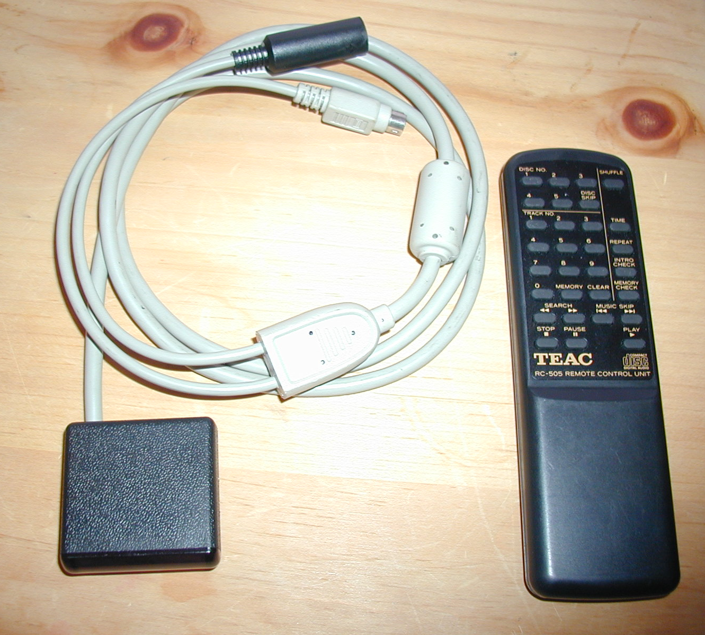
Figure 2 ATir assembled view with remote

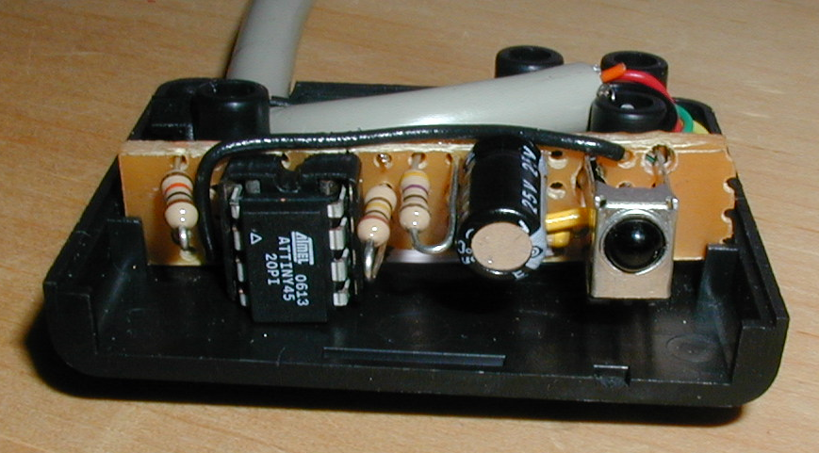
Figure 3 ATir internal view

Using a keyboard, the ATir is programmed to respond to a key press on the remote control and outputs a block of keyboard data. For example the ATir could be programmed to work with Microsoft power point by entering program mode, selecting a button on the remote control (say our remote has a “play” button that we select), typing the F5 key, and saving the keyboard macro by pressing the same button on the remote. Now with power point started, when you press the play button on the remote, ATir sends the codes for press and release of the F5 key, and the power point presentation starts. To go to the first slide in power point, the keyboard shortcut 1 + ENTER can be used. This keyboard macro could be linked with some other remote control pushbutton.
Key sequences up to 64 keys can be stored in an individual macro, and these macros are store in the EEPROM section of the microcontroller, so the data is retained after power is removed. After macros are defined, the ATir can be connected to a PC without a keyboard, and the ATir will perform the necessary handshaking during boot up to allow operation. A keyboard can be connected to the ATir after the system boots, and the ATir will relay information between the keyboard and PC.

AT keyboard operation
The AT keyboard is configured with a 5 pin din connector, or a 6 pin mini din (commonly referred to as PS2) connector. The interface is comprised of 4 wires, namely 5V, ground, clock and data. The clock and data lines implement a bidirectional synchronous serial bus. The bidirectional nature of the bus allows the PC to send select messages to the keyboard (such a retransmit last byte or turn on the caps lock LED) as well as the normal traffic from the keyboard to the PC.
Key press information is transmitted in the form of a scan code. For example the “A” key sends a code of 0x1C when pressed and 0xF0 0x1C when released. The key press and key release are coded separately to allow multiple keys to be pressed simultaneously (such as when using the shift key to type a capital letter). The format for a scan code is an 11 bit frame consisting of a start bit, 8 bit code, odd parity bit and stop bit. The frame timing diagram for keyboard to PC (host) communication is show in figure 4. PC to keyboard communications is initiated by the PC by placing the bus in a request to send condition, which signals the keyboard to clock in the command. This communication is shown in figure 5.

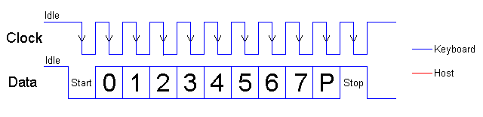
Figure 4 Keyboard to PC (host) AT keyboard communication waveform
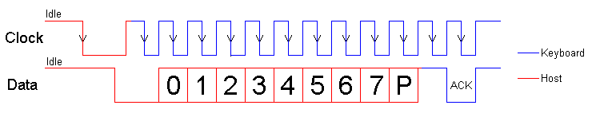
Figure 5 PC (host) to Keyboard communication waveform

IR remote operation
The infrared remote used for this project transmits a 32 bit packet consisting of a 16 bit address field, an 8 bit command field and an 8 bit command complemented field for error detection. The IR signal is modulated by the IR remote at approximately 38kHz. Other modulation frequency receivers are available in the Sharp GP1UM27XK series from 36kHz to 40kHz. With no signal the device outputs a high value, and will drive the input low with the presence of a modulated IR signal. For the remote control used, a logical 1 is represented by a short pulse of approximately 540µs, and a logical 0 is represented by a long pulse of 1640µs, with a 570µs delay between pulses. Most of the discrete components used in this project comprise the low pass filter recommended in the Sharp GP1UM27XK datasheet.
The ATir was designed to support a variety of remote controls by reading remote control commands at run time, and not relying on particular commands from a particular remote. The remote used was a surplus unit from All Electronics, a TECH model RC505, but other remote controls could also be made to work. Although the 16 bit address field is decoded by the ATir, it is ignored so that other remotes with different ID values can be used with no modification to the code. A universal remote control can be configured to work with the ATir, as well as extra remote controls one may have that are not being used (that modulate at the same frequency and uses a common 32 bit frame format).

ATir Description
The ATir device is used to interface an infrared remote control to a PS2 keyboard port, where a key on the remote corresponds to a programmable keyboard macro. The device has male and female mini din connectors that are intended to be connected inline with a PS2 keyboard, but using a keyboard is optional. When a keyboard is attached to the device, the device relays scan codes and command information to and from the PC and the attached keyboard. If a keyboard is not connected, the device will perform the required handshaking with the PC simulating the response of a keyboard. Without this capability the PC bios would determine that a keyboard is not connected and either present the user with a keyboard error message and halt, or turn off the port to save power.
The device hardware is composed of an Atmel™, ATiny45 microcontroller, a Sharp™ infrared receiver / demodulator and a few discreet components consisting of low pass filter components and pull up resistors. Refer to figure 6 for the schematic diagram of the ATir. The ATtiny45 microcontroller IC1 is an 8 pin device that contains 4K bytes of flash program memory, 256 bytes of SRAM and 256 bytes of EEPROM. The microcontroller also contains 2, 8 bit timer/counters, Universal serial interface and a 10 bit successive approximation analog to digital converter.

The keyboard clock line is connected to the external interrupt pin, and the interrupt is configured for falling edge detection. The output of the IR detector IC2 is sensed using the pin change interrupt with a mask configured to sense only the IR detector output. To save space and components, the internal pull up feature is used instead of external pull up resistors for the required PC clock and data lines. A high resistance pull up R5 is used on the keyboard clock line to allow operation with a keyboard disconnected while being able to sense and operate a keyboard when connected. Resistor R4 and LED1 were used during development and gives a visual indication whenever the ATir is transmitting data to the PC. This occurs when a key is pressed on an attached keyboard or when an IR command that is linked to a valid keyboard macro is received. Indicator connection is possible because the ATir always generates the clock signal and the tiny45 has no trouble driving LED’s directly from an IO pin.

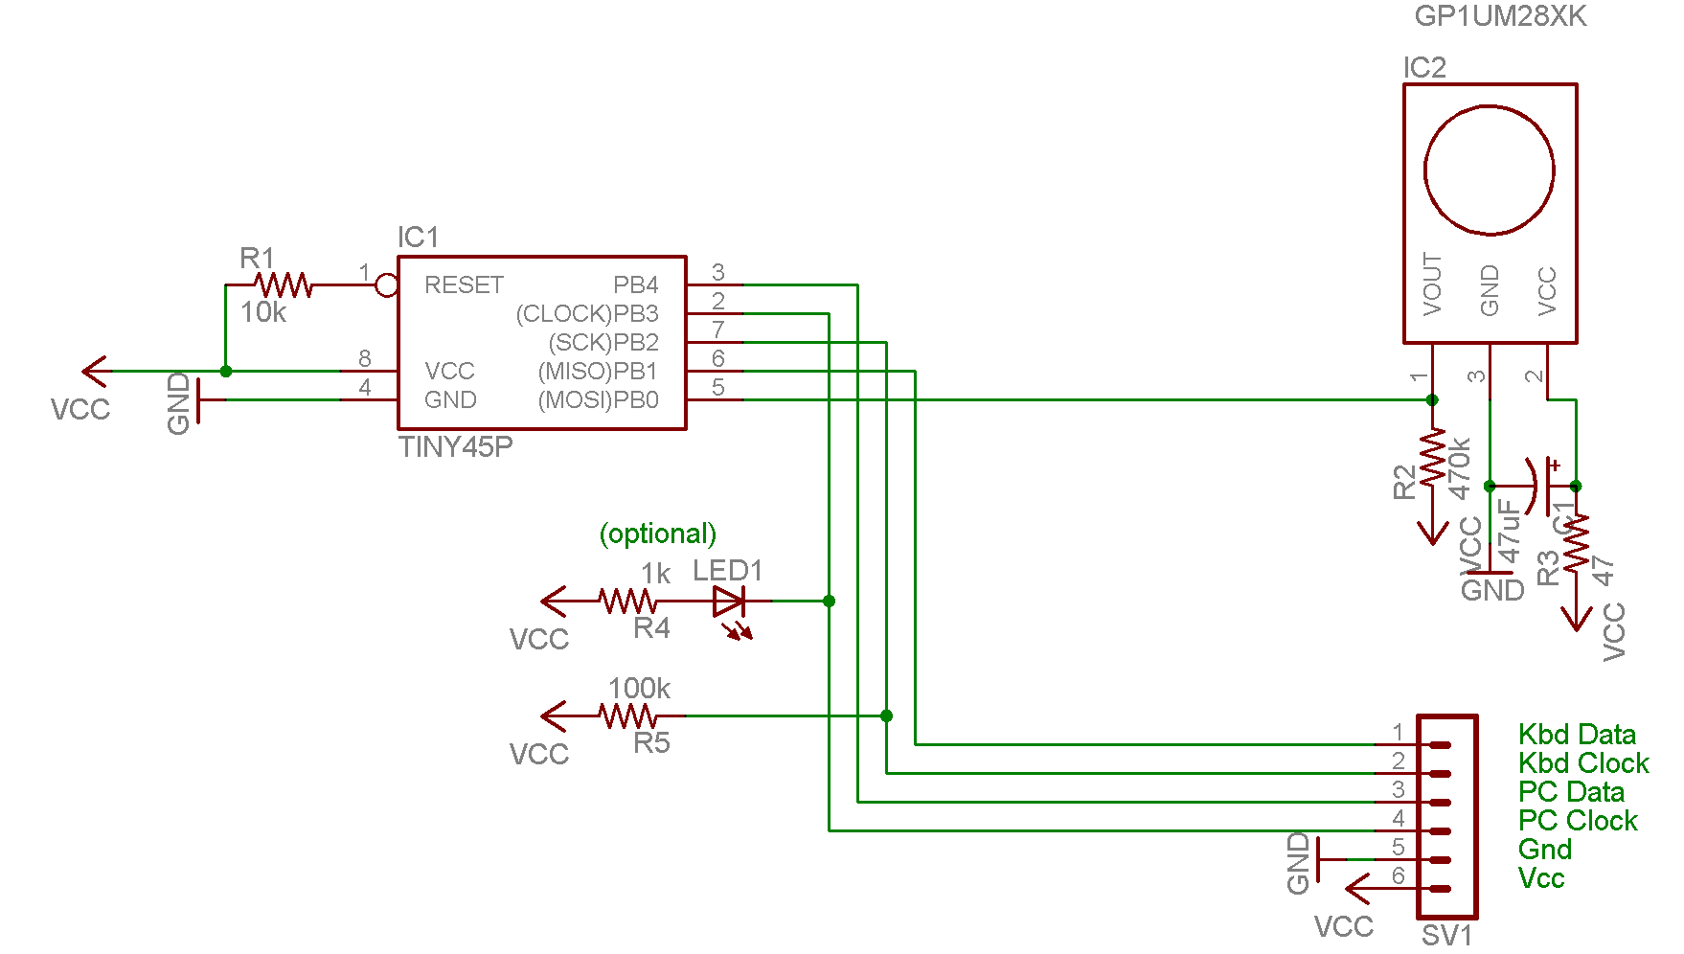

Figure 6 ATir Schematic Diagram

The internal, calibrated 8MhZ clock was used as a clock source for the ATir. This source proved to be surprising accurate, as the timing requirements for the AT keyboard data communication and IR pulse length timing require a consistent and accurate system clock.
Most of the digital resources of the ATtiny45 are used in this project. Timer 0 is used to time the pulses from the IR receiver. Timer 1 is used to implement a timeout condition during transmit and receive to ensure that synchronous communications remain synchronized. The EEPROM section is used to store IR commands and the associated macro data. Program memory utilization is a few bytes short of tiny45’s 4K capacity. All of the IO pins are utilized. The reset pin has the capability of being reconfigured as general purpose IO, but this feature was not implemented because reprogramming of the chip would then require a high voltage programmer vs the inexpensive parallel port programmer that was used.
The microcontroller source code was developed in C using AVR GCC in AVR Studio 4 version 4.12 development environment. As a hobbyist with a budget, I thoroughly enjoyed working with the FREE AVR GCC compiler that integrates nicely with AVR Studio. Initially code was written and tested using the built in simulation tools in AVR Studio for a 40 pin ATmega32 as the target. Next the application was programmed into the ATmega for in circuit debugging. This allowed for easy programming and debugging by using a JTAG ICE, and asynchronous serial hardware to send scan code information to and from the device to a PC running a terminal program. The ATmega also had plenty of spare IO lines to run a LCD display and output signals to capture events on an oscilloscope. After the application was running on the ATmega, some minor architectural changes allowed the application to be ported on the ATtiny using the same complier and development environment, very nice. Another debugging option is “debug wire” one wire debugging feature of the ATtiny, but this requires a JTAGICE mkII, which didn’t fit into the budget.
The original plan was to port the application to the ATtiny85, which is physically the same chip with double the memory (program,sram,eeprom) than the ATtiny45. Unfortunately this chip was not available during development, requiring a lot of cutting (and almost hammering) to get the application to fit.
The application places some real time signal processing demand on the microcontroller. Reception of data from the keyboard must be processed and retransmitted to the PC. Keyboard data is processed by a filtering and compression algorithm when recording macros to conserve EEPROM memory. A key press and release sequence causes the keyboard to transmit 3 or 5 scan code frames comprised of 11 bits/frame. This sequence is represented by storing 1 byte in EEPROM. Also as most everyone has experienced, if a key character key is held down in an application such as a word processor, the character repeats until released. This is because the keyboard resends the key down scancode at a configurable periodic rate, referred to as the typematic rate. This typematic data is filtered and therefore does not contribute to storage requirements. The compression algorithm is shown in listing 1.

void encode(uint8_t scancode){
static bool ext = false; //extended key flag
static bool rel = false; //key release flag
static bool lwc = false; //last (input) was a code byte (not ext or rel)

static uint8_t lastcode = 0;

switch (scancode){
case 0xE0:
if (lastcode && !ext){
addKeyDown(lastcode);
lastcode = 0;
}
ext = true;
lwc = false;
break;
case 0xF0:
rel = true;
lwc = false;
break;
default:
if (scancode==lastcode){
if(rel){ //if release, its a keypress
rel=false;
if(ext){
ext = false;
addKeyPressExt(lastcode);
}
else{
addKeyPress(lastcode);
}
lastcode = 0;
}
else{
if(ext && lwc){
addKeyDownExt(lastcode);
ext = false;

}
}
}
else{//scancode != lastcode
if(lastcode){ //a key was pressed pending
if(rel){
rel=false;
if(ext){
ext = false;
addKeyDownExt(lastcode);
addKeyReleaseExt(scancode);
}
else{
addKeyDown(lastcode);
addKeyRelease(scancode);
}
lastcode=0;
}
else{
if(ext){
addKeyDownExt(lastcode);

if(lwc)
ext = false;
}
else{
addKeyDown(lastcode);
}
lastcode=scancode;
}

}
else{ //key not pressed pending
if(rel){
rel = false;
if(ext){
ext = false;
addKeyReleaseExt(scancode);
}
else{
addKeyRelease(scancode);
}
lastcode=0;

}
else{

lastcode=scancode;
}
}
}
lwc=true;
}//end switch

}
Listing 1 compression and storage algorithm

Operation
To program keyboard macros using the ATir, simply plug the male connector into the PS2 keyboard port of the PC, and plug your keyboard into the female connector of the ATir and boot your computer. Open your favorite text editor, for windows notepad is sufficient. To enter programming mode, a key sequence is entered on the keyboard. To prevent the ATir from going into program mode during normal typing tasks, I chose a keyboard sequence that is somewhat abstract, and necessary so. Type the following sequence:

- hold the RIGHT shift key down
- press and release the LEFT shift key
- release the RIGHT shift key

Hopefully you have never used that sequence before with normal computing tasks. Now, if by some extremely fast magic speed typist, text should be scrolling onto the screen prompting you to press a button on the remote. If the key sequence above is reentered at this stage, the EEPROM is cleared. To program a macro, point your compatible remote control at ATir and press a button. If decoded successfully, the command byte is displayed and the user is prompted to enter macro and press the same button to record. Type in your macro and when finished, press the same button on the remote control to confirm the macro and record it. If a macro does not exist for the command selected, a prompt will indicate that the macro was recorded successfully. Now when you press the remote control button, the keyboard macro sequence is sent to the PC. Reenter program mode to set up additional macros for other keys on the remote. The following is an example programming session.

Press button on remote to program

Command = EF
Type in macro now
Press the same button on remote to accept
Hello World

Command = EF
IR command match
Macro write OK
Hello World
Hello World

Conclusion

The Tiny AVR IR keyboard interface offers a convenient cross platform solution to interface an IR remote control to type keyboard macros to a PC. The interface plugs into a PS2 keyboard port on the PC and accepts commands from an infrared remote. The device can be configured to operate with common remote controls with little or no change in code. For those of us with laptops or new computers without PS2 ports, do not despair. USB to PS2 adapters are inexpensive and allow the ATir to also be used within USB environments. Other remote control for PC’s are available, but the ones I have seen require the use of the remote control supplied, and drivers to be installed. With ATir, any operating system that recognizes the hardware will work. The ATir device has few components, and the system as constructed is about $10.

http://www.beyondlogic.org/keyboard/keybrd.htm, Craig Peacock
http://www.beyondlogic.org/keyboard/keybrd.htm, Craig Peacock

